**PROJECT DOCUMENTATION**

**INDIAN AGRICULTURAL CROP PRODUCTION ANALYSIS (1997 – 2021)**

**INTRODUCTION:**

**Overview:**

This report delves into the captivating realm of India's agricultural cultivation, providing a comprehensive visual exploration of key aspects and trends in the agricultural sector. Through the visual representations, readers can gain valuable insights into crop production, seasonal variations, regional distribution, and overall production trends. These visualizations enable intuitive analysis, allowing stakeholders to uncover patterns, identify areas of growth or concern, and make data-driven decisions.

**Purpose**:

By harnessing the power of Tableau, this report not only presents the data in a visually appealing manner but also provides an interactive experience for readers to explore the intricacies of India's agricultural cultivation. To Extract the Insights from the data and put the data in the form of visualizations, Dashboards and Story we employed Tableau tool.

**PROBLEM DEFINITION AND DESIGN THINKING**

**Empathy Map:**

An empathy map is a template that organizes a user’s behaviours and feelings to create a sense of empathy between the user and your team. The empathy map represents a principal user and helps teams understand their motivations, concerns, and experience. Empathy mapping is a simple yet effective workshop that can be conducted with various users in mind, anywhere from stakeholders, individual use cases, or entire teams of people. Many teams, such as design teams, sales, product development, and customer service, can conduct it. Essentially, an empathy mapping exercise is a practice that seeks to get inside the head of the customer as they interact with your product/service.

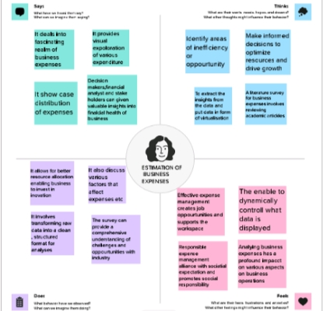

**Brainstorming Map:**

Brainstorming is a group creative thinking by which efforts are made to find a conclusion for a specific problem by gathering a list of ideas spontaneously contributed by its members. In other words, brainstorming is a situation where a group of people meet to generate new ideas and solutions around a specific domain of interest by removing inhibitions. People are able to think more freely and they suggest as many spontaneous new ideas as possible. All the ideas are noted down without criticism and after the brainstorming session the ideas are evaluated**.**

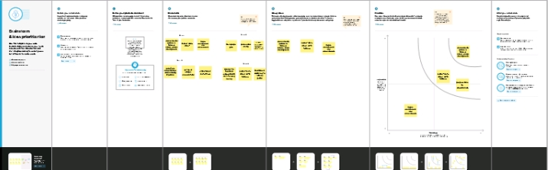

**Business Requirements:**

The purpose of business requirements is to define a project’s business need, as well as the criteria of its success. Business requirements describe why a project is needed, whom it will benefit, when and where it will take place, and what standards will be used to evaluate it. It generally not defines *how* a project is to be implemented; the requirements of the business need do not encompass a project’s implementation details. To illustrate this, one wiki defines business requirements as being “expressed in terms of broad outcomes the business requires, rather than specific functions the system may perform. Specific design elements are usually outside the scope of this document.”Another note is that business requirements “describe in business terms what must be delivered or accomplished to provide value.

### Data Preparation:

Data preparation, also known as data pre-processing, is a crucial step in the data analysis process. It involves transforming raw data into a clean, structured, and suitable format for analysis. Proper data preparation ensures that the data is accurate, consistent, and ready to be used effectively to derive meaningful insights.

### Data Visualization:

### Data visualization is the process of creating graphical representations of data in order to help people understand and explore the information. The goal of data visualization is to make complex data sets more accessible, intuitive, and easier to interpret. By using visual elements such as charts, graphs, and maps, data visualizations can help people quickly identify patterns, trends, and outliers in the data.

### No of Unique Visualizations:

The number of unique visualizations that can be created with a given dataset. Some common types of visualizations that can be used to analyze the performance and efficiency of a project include bar charts, line charts, heat maps, scatter plots, pie charts, Maps, etc. These visualizations can be used to compare performance, track changes over time, and show distribution, and relationships between variables.

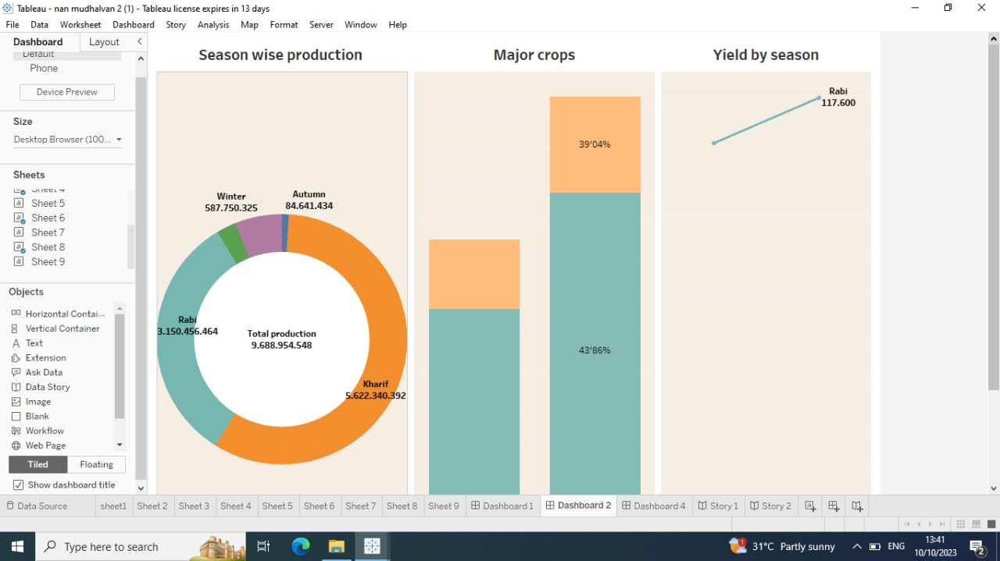

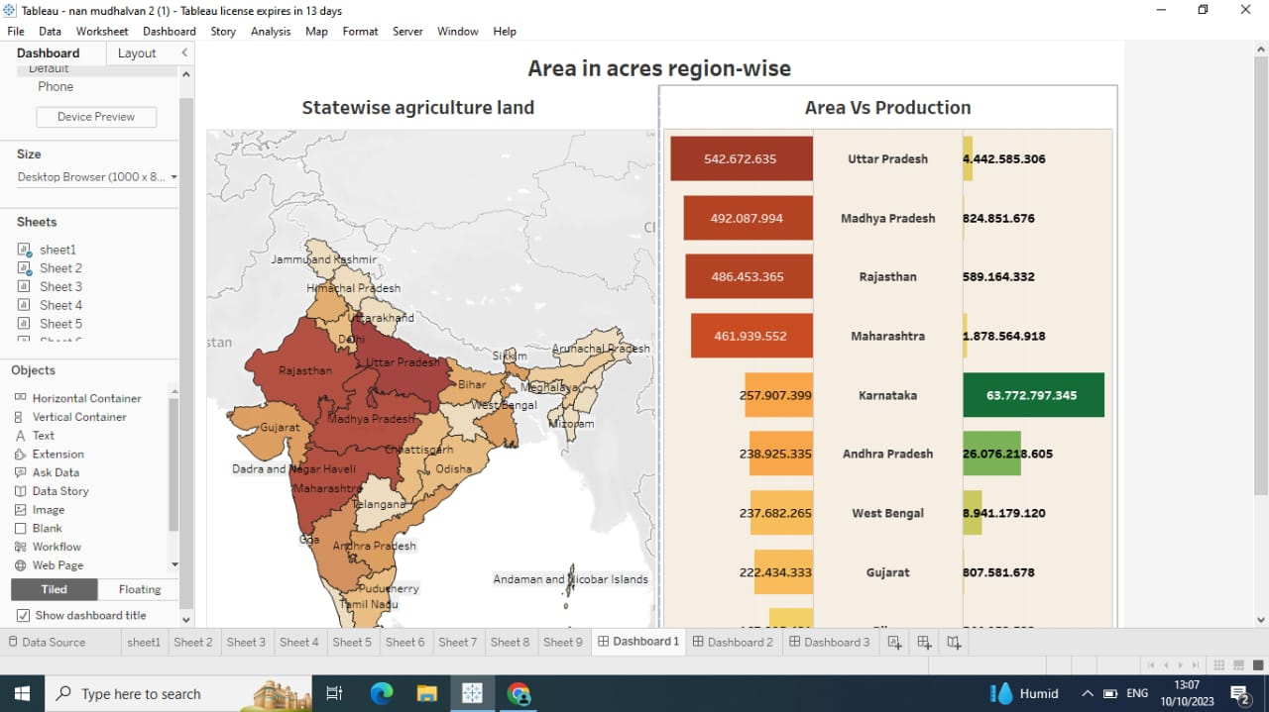

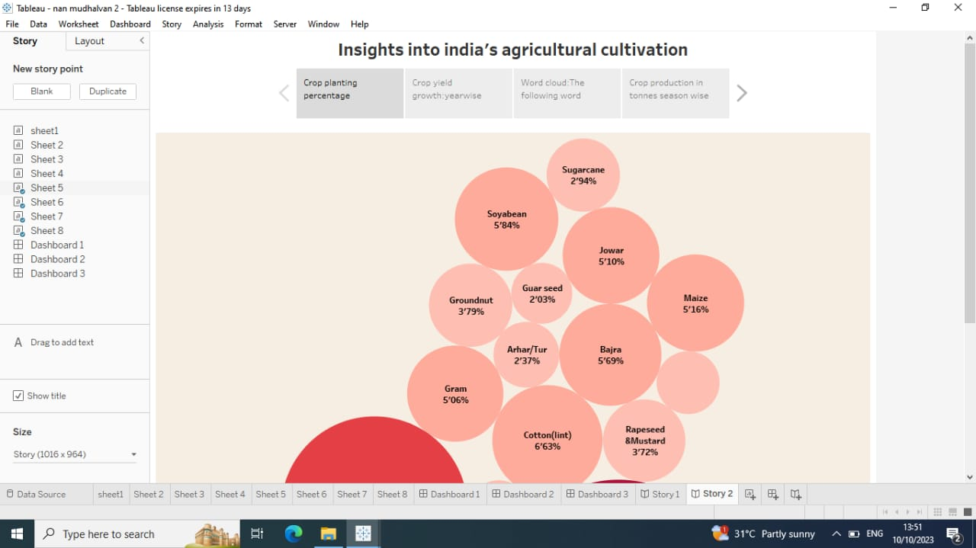

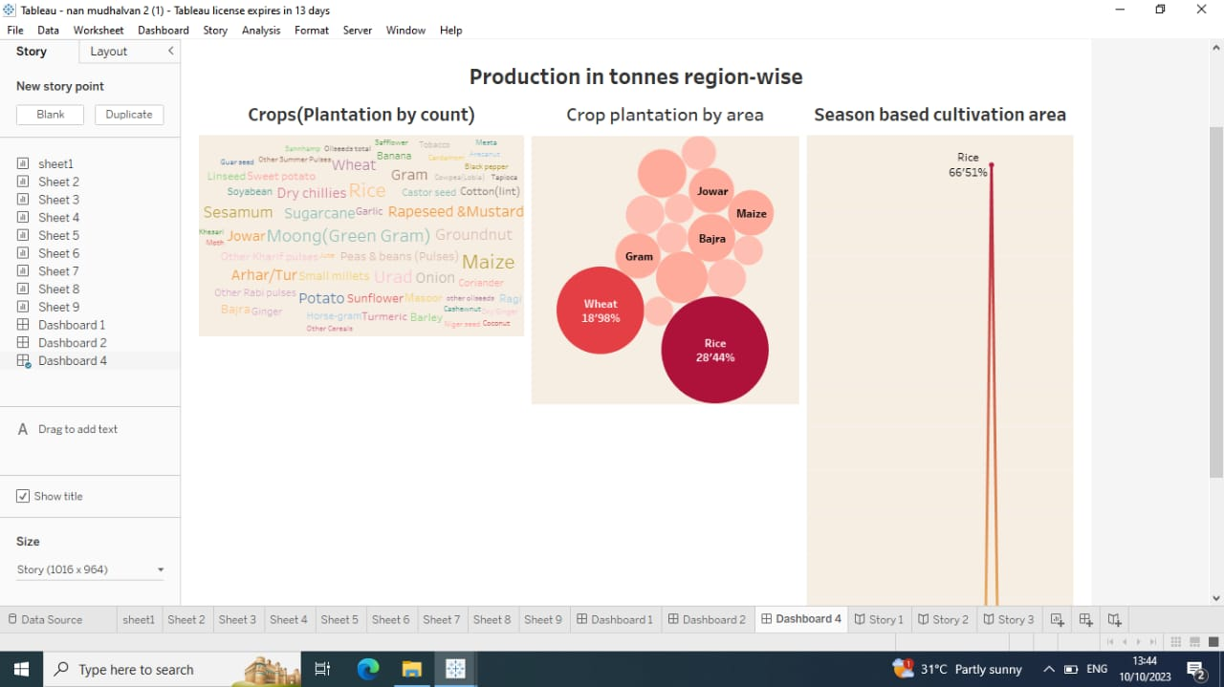

**ADVANTAGES:**

* Food Security
* Economic Growth
* Export and Trade
* Rural Development
* Income Generation

**DISADVANTAGES:**

* No insurance against crop failure
* No diversification of farm produce
* Crops may be attacked by pests and disease's
* Weather and climate may affect crop productivity.
* Farmers have only one source of income.

**APPLICATION:**

For thousands of years, agriculture has played an important role in everyday life. Before agriculture, hunting and gathering enabled humans to survive. It wasn’t until the transition to the planned sowing and harvesting of crops that humans began to thrive. Humans developed tools and practices to improve agricultural output with more efficient means of sustaining themselves. From there, innovations that created industries led to the modern era.Today, the importance of agriculture in everyday life can’t be minimized. Without the agriculture sector, activities such as getting dressed for work and cleaning the home wouldn’t be possible.

**FUTURE SCOPE:**

Indian agriculture production has increased with time due to the latest trends in India. It has made us self-reliant and prevented us from becoming a begging bowl for food as a net exporter of agriculture and other products after independence. As per the Second Advance Estimates for 2019-20, the total country’s food grain production is estimated to be a record 291.95 million tonnes. It is good news, but the Indian Council of Agricultural Research (ICAR) forecasts that the demand for food grains will increase to 345 million tonnes by 2030. These all things are happening because of agriculture trends. Recent trends in Indian agriculture means new technologies and developments in recent years in the agriculture sector.

**CONCLUSION:**

Crop production is an essential aspect of agriculture and is crucial for feeding the world's growing population. It involves various steps such as land preparation, planting, watering, fertilizing, pest control, and harvesting. Crop production is important for food security, the economy, and the environment. There are several types of crops that are grown for food, feed, fuel, and fibre, and there are different methods of crop production that can be used depending on the crop, the climate, and the soil. By understanding the importance of crop production, we can work towards a more sustainable future for agriculture and the planet.

DOCUMENTATION BY

1. SUJITHA S
2. ABI S M
3. PRABISHA R
4. AJEESHA R